

Currency Converter User Guide

JULY 2021

# 

**REVISION HISTORY**

|  |  |  |  |
| --- | --- | --- | --- |
| **Version** | **Date** | **Comments** | **Author** |
| **0.1** | **2 July 2020** | **First version of user guide created** | **Ron** |
| **0.2** | **5 July 2020** | **Updated installation instructions with creation of executable file** | **Ron** |

**TABLE OF CONTENTS**

1. Introduction…………………………………………………………………………………………………………...3
2. System Requirements…………………………………………………………………………………………….3
3. Installation……………………………………………………………………………………………………………..4
4. Operation……………………………………………………………………………………………………………….4
5. Troubleshooting……………………………………………………………………………………………………..7

# 

# 

# 

# Introduction

1. The Currency Converter program is a simple GUI-based application that allows a user to select currency conversion options for the top 11 currencies acknowledged from [www.x-rates.com](http://www.x-rates.com). This application will also retrieve up-to-date currency rates from the web site and execute proper currency conversion as requested by the user’s desired currency types and value.

# 

# System Requirements

Currency Converter Minimum System Requirements:

1. **Operating System:** Mac, PC, or Linux
2. **Memory:** Minimum of 128 MB RAM
3. **Processor:** Pentium 2 266 Mhz processor or faster
4. Latest version of Java compatible with your OS. ([Link](https://www.java.com/en/download/manual.jsp))

# 

# Installation

1. Source code can be downloaded from the following link:  [CurrencyConverter](https://github.com/auhroy/CMSC495-Group-4-Currency-Converter/archive/refs/heads/main.zip)

2. Navigate to the saved destination of the code and extract the zip file contents.

3. Navigate into the /dist directory and double click on the CurrencyApp executable

file to run the program. (Tip: Create a shortcut on your desktop for easy access)

# 

# Operation

1. Choose currency for conversion in the first drop down menu.

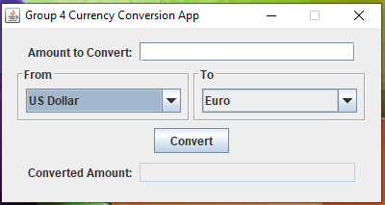

1. Choose the currency type to be converted to from the second drop down menu in numerical format.



1. Enter the numeric currency dollar value for conversion in the ‘Amount to Convert’ field.

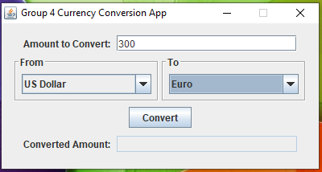

4. After the desired currency types are selected with the dollar value for conversion

entered in the application, click on the ‘Convert’ button to execute the conversion.



5. Result will be displayed in the ‘Converted Amount’ field after successful currency

conversion.

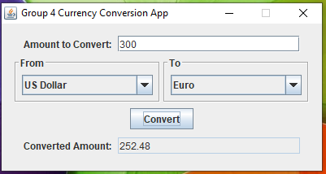

# 

# Troubleshooting

1. **Improperly formatted currency value** - Check input value and make sure it is a positive numeric value.

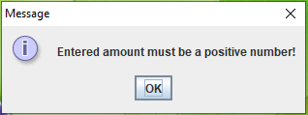

2. **Internet connectivity issues** - Check user internet connectivity. If operable, there is a connectivity issue with the web service providing up-to-date conversion rates. In this instance, the user will still be able to use the application using back-up currency conversion rates embedded within the application.

